Gunalan Karun (gk5483), Jiacheng Jason He (jjh3262)

FIFA 3K19

Our game will be a Foosball table simulation. The goal of the game is to be the first player to score 7 points.

**Controls**

Each player will control 3 rows of football players using a total of 6 potentiometers. There will be a “kick” button which will replicate twisting the foosball stick (essentially causing the ball to bouncing faster if pressed when the ball hits the player).

**Gameplay**

The ball will initially be placed in the center of the table and will stay stagnant until one of the player hits the “kick” button. The ball will then bounce the other side and both players will have the opportunity to block and hit the ball trying to prevent the ball from going into their respective goals. Once the ball goes into a goal the other player receives a point and the ball is reset to the center. The player who was scored on has the opportunity to start.

**Rules**

There are no complicated rules since the game defines the boundaries of the board. If the ball hits the side of the game board (edge of LCD screen) it will bounce according to physics and continue. In terms of foosball player arrangement, the first row (closest to goal) will have one player, the second row will have 2 player and the third row will have 4 player for each side respectively. When the kick button in pressed. All player on the team will perform the kick action. Every goal counts as one point.

**Sound Effects**

Every time a goal is scored, a sound effect will be played. Every time the ball hits the edge of a wall or is kicked by a player other sounds will be played. When a victory is achieved a celebration sound will be played.

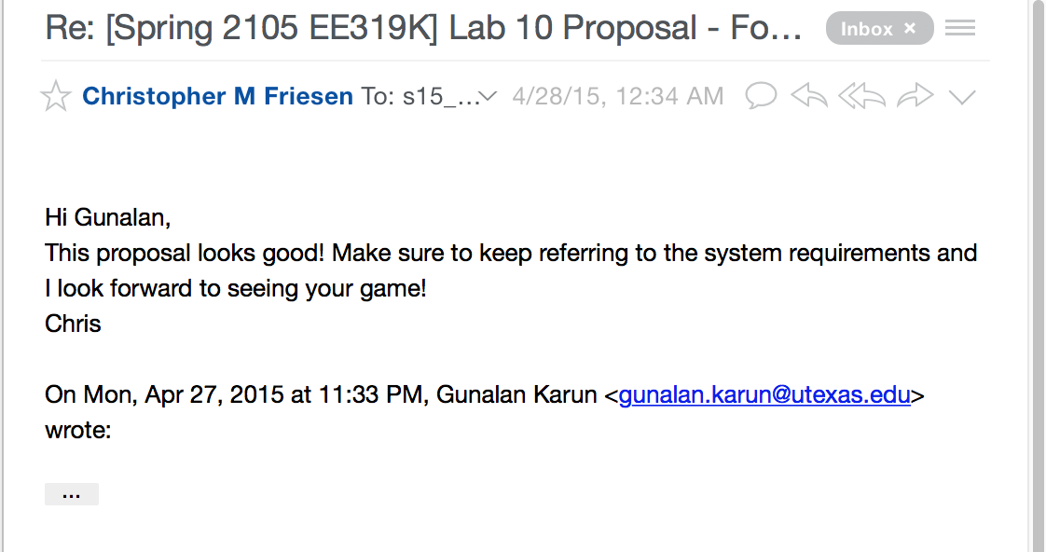**Hardware Used**6 potentiometers, 3 external buttons, 1 audio jack (sound output), 1 LCD display